**How to Update VDI region to Dutch(Netherlands) and excel separator?**

1. Search for **Region and Language** in Start Menu

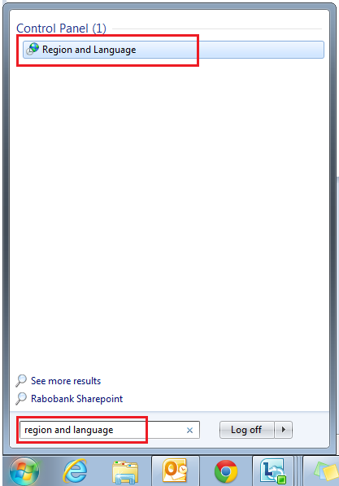

1. Change **format** to **Dutch(Netherlands)**

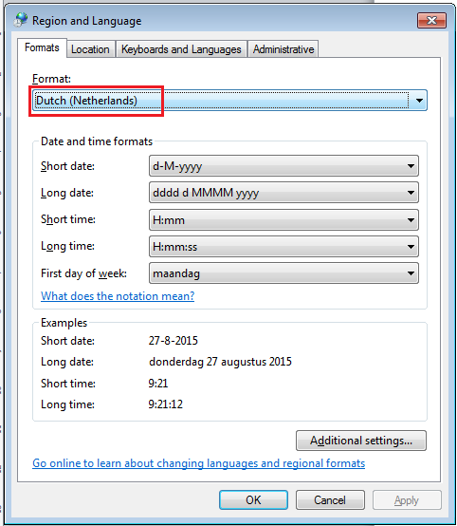

1. Click on Additional Settings….
2. Update **Decimal symbol** to “.” [dot]
3. Update **List separator** to “;” [semicolon]

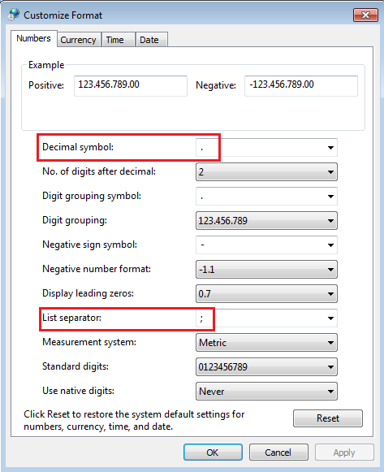

Then Ok🡪Ok ☺

1. Update the separator in MS-Excel.

File🡪Options🡪Advanced🡪check ‘Use system separators’

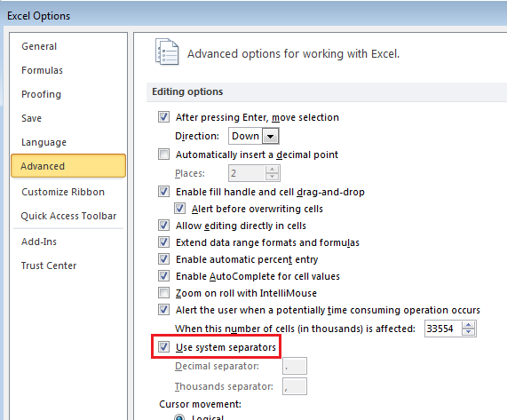

Done…!

For Time travel test cases, don’t forget to update your VDI time zone to **[(UTC+01:00) Amsterdam, Berlin, Bern, Rome, Stockholm, Vienna]** with **day light saving enabled**.

Thank you. ..! ☺